**Unit 1 Lesson #5**

**Modeling with Quadratic Functions (Getting Equ w Calculator)**



**Objective: To model data with quadratic functions.**

**Big Idea: Three noncollinear points, no two of which are in line vertically, are on the graph of**

**exactly one quadratic function.**

**Learning Targets**

SWUT:

Three non-collinear points (Points that do not form a straight line), none of which are in a line vertically, are on the graph of exactly one quadratic function.

Given three non-collinear points, the quadratic equation can be written using standard form.

The quadratic regression feature on a calculator can be used to find a quadratic model for a given set of data.

The maximum/minimum features on a calculator can be used to find the maximum/minimum points on a parabola.

(Any quadratic function is possibly a stretch, compression, reflection and/or a translation of the parent function $y=x^{2}$.)

**INTERESTING FACT:**

**For a parabola, degree 2 (largest exponent is a 2), you need 3 points.**

**You always need 1 more point than the degree of the equation or function.**

**Ex1. A parabola contains the following three points: (0, 0 ), (-1, -2 ), (1, 6 )**

**Write the equation of this parabola in standard form.**

 **<HINT: “stat” “edit”>** 

**Ex2. A parabola contains the following three points: $\left(0,0\right), \left(-1, 1\right), and \left(1,5\right).$**

**Write the equation of this parabola in standard form.**

**Ex3.** Campers at an aerospace camp launch rockets on the last day of class.

The path of Rocket 1 is modeled by the equation $h=-16t^{2}+150t+1$

where $h$ is the distance from the ground and $t$ is time in seconds.

The path of Rocket 2 is modeled by the graph at the right. Which rocket flew

higher? Justify your answer.

**Rocket 2**

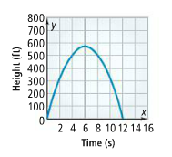

Ex 4. **PUMPKIN TOSSING**. A pumpkin tossing contest is

held each year in Morton, Illinois, where people

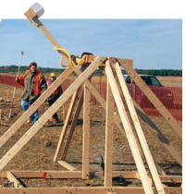compete to see whose catapult will send pumpkins

the farthest. One catapult launches pumpkins from

25 feet above the ground at a speed of 125 feet per

second. The table shows the horizontal distances

(in feet) the pumpkins travel when launched at different

angles.

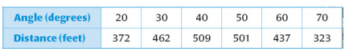

1. Use a graphing calculator to find the best-fitting quadratic model for the data. How well does this model fit your data (HINT: need R2)? Explain.

Diagnostics ON!

Ex 5. **RUNNING.** The table shows how wind affects a runner’s performance in the 200 meter dash. Positive wind speeds correspond to tailwinds, and negative wind speeds correspond to headwinds. The change t in finishing time is the difference between the runner’s time when the wind speed is s and the runner’s time when there is no wind.

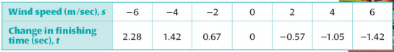

1. Use a graphing calculator to find the best fitting quadratic model.
2. Predict the change in finishing time when the wind speed is 10 m/sec.

**Ex6. The table below shows the horizontal distance (in feet) traveled by a baseball hit at various angles. The initial speed of the ball off the bat is constant.**

1. 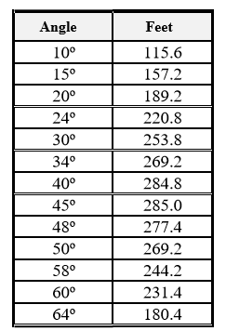 Determine a quadratic regression model equation to represent this data.
2. Graph the scatter plot on the grid below.

Be sure to state your scale and label each axes.

1. Is the new equation a “good fit” to represent this data? Explain how you made your decision.
2. Based upon the new equation, what distance, to the nearest foot, will correspond to an angle of 5 degrees?
3. What angle, to the nearest degree, will correspond to a distance of 270 feet?

NO HOMEWORK ☺